Discussion 1

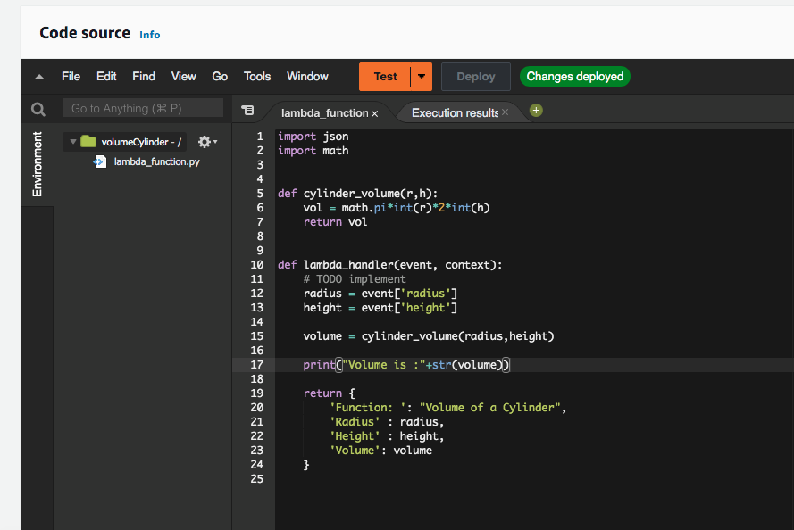
The main lambda handler took the event dictionary as one of its arguments.
The dictionary had two keys, radius and height.

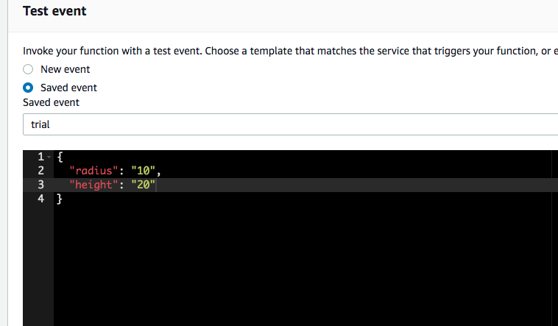

The Cylinder radius was 10 and height 20 for the test event.

The values were passed into the cylinder_volume function as arguments. These functions returned the volume of the cylinder and the value is stored in variable volume.

The lambda handler then returned the radius, height and volume as output.

